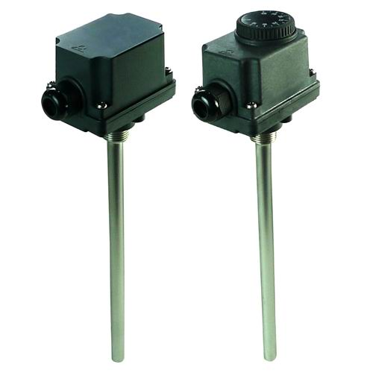

Type Y048 & Y049
Rod thermostats
Housing: IP44, black PC-ABS, UL94V0.
Cable input: One M20 cable gland.
Set point adjustment: By printed knob for external adjustment models, by screw driver and printed dial on internal adjustment models.
Sensing element: 304L stainless steel or nickel plated brass.
Adjustment ranges: -35+35℃, 4-40℃, 30-90℃, 30-110℃.
Rod length: 90, 230, 300 mm. Other length on request.
Mounting: by the ½” BSPT pocket fitting.
Contact: SPDT.
Electrical rating: 20A 250V.
Minimum storage temperature: -35℃ (-30°F).
Maximum ambient temperature: 60℃ (140°F).

